SYSTEM SUMMARY: HOW SEASONAL HUBS, MICRO-EDITS, CATEGORY PAGES & PRODUCT PAGES WORK
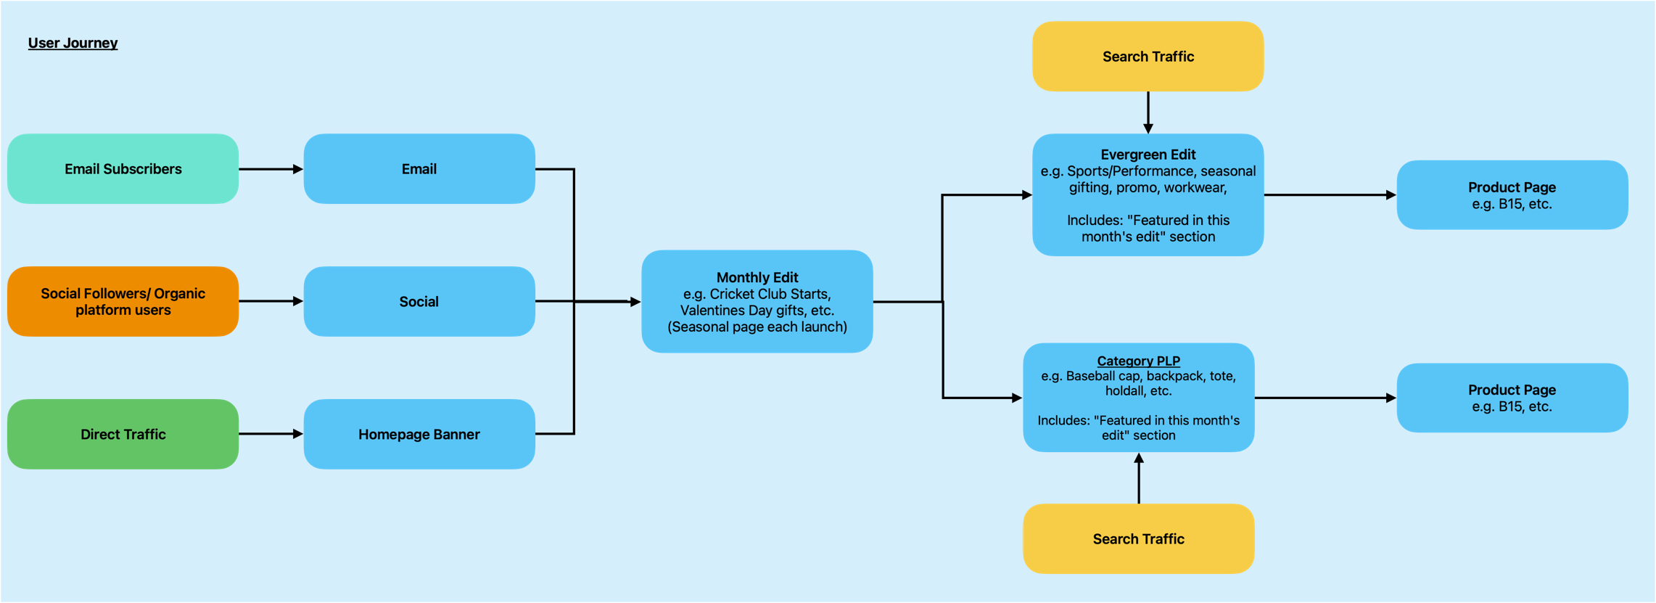

1. Seasonal Hub (Quarterly)
What it is:
A top-level campaign page that introduces the overarching theme for the season (e.g. SS26, AW25).
What it contains:
- Seasonal message
- Visual identity for that season
- Links to all current micro-edits (monthly edits)
- Links to key product areas (categories, evergreen edits)
How it behaves:
- Published once per season
- Used mainly at seasonal launch
- Supports SEO (acts as a container/anchor page)
User traffic sources:
- Homepage secondary banners
- Navigation menu
- Some search traffic (seasonal keywords)
- Sometimes launch email

2. Micro-Edits (Monthly Edits)
What they are:
Monthly campaign pages with editorial storytelling + a small curated group of products.
What they contain:
- 100–200 word editorial intro
- Monthly theme (e.g. New Year fitness, gifting, colour, sustainability, festival, heritage)
- 3–6 hero products for that month
- Links to PDPs, category pages, and seasonal hub
- Imagery or lifestyle story
How they behave:
- These are the main landing pages for:
  - Monthly email
  - Homepage hero
  - Social campaigns
- They rotate monthly.
- They link “up” to the seasonal hub and “down” to products.
User traffic sources:
- Email (primary destination)
- Homepage hero
- Social
- Internal links from evergreen edits / categories

3. Category Pages (PLPs – product type)
Examples: Dad Caps, Beanies, Tote Bags, Backpacks.
What they are:
Permanent product list pages grouped by product type.
What they contain:
- Intro paragraph about the category
- Filters, product grid
- “Featured in this month’s edit” module (dynamic in future phases)
- Links to PDPs
- Optional breakouts (e.g. “Dad Caps for Promo”, “Dad Caps for Workwear”)
How they behave:
- Always-on SEO pages
- Users land here from Google for generic searches (“dad caps”, “tote bags”)
- They surface monthly edit content as a module
User traffic sources:
- Search
- Navigation
- Internal links from micro-edits

4. Evergreen Edits (Permanent thematic edits)
Examples: Workwear, Sustainability, Festival, Outdoor, Back to School.
What they are:
Permanent “interest-based” pages (“why you need it”), not product type (“what it is”).
What they contain:
- 150–250 words of intent-based content
- Product highlights
- Links to PDPs
- Featured this month module (future)
- Links to related categories (e.g. “Shop all Tote Bags”)
How they behave:
- Always-on SEO pages for mid-funnel search intent
- Provide context and storytelling deeper than category pages
- Connected to monthly edits (micro-edits push traffic into them)
User traffic sources:
- Search (intent-based terms)
- Homepage secondary modules
- Internal links from micro-edits

5. Product Pages (PDPs)
What they are:
The final pages featuring a single SKU.
What they contain:
- Product details, images, materials, sustainability info
- Decoration opportunities
- Links to categories, evergreen edits, and newest micro-edits
How they behave:
- These are the conversion pages
- Traffic from all levels flows down into them
User traffic sources:
- Direct from micro-edits
- From categories
- From evergreen edits
- From search

